
Vacancies - Reducing BAME Employment Gap
Week Commencing 7th June 2021


The Kickstart Scheme is a 6 month paid job placements for 16 to 24 year olds on Universal Credit who are at risk of long term unemployment. Work with a local employer, funded by the Government. It provides a fully funded opportunity for young people to gain experience of working in some of Britain’s most exciting companies.
The placements are available enabling you to learn new skills and acquire a sound knowledge of the company, working 25 hours per week, 6 months paid at National Minimum Wage, learn new skills, variety of opportunities with lots of employers available.
Interested in a Kickstart Placement:
- Please contact your DWP Workcoach for more information about the Kickstart placements available.

Journal Message Black and minority ethnic (BAME) candidates are encouraged to apply for a Kickstart Placement - The Kickstart Scheme is a 6 month paid job placements for 16 to 24 year olds on Universal Credit who are at risk of long term unemployment. with a local employer, funded by the Government. It provides a fully funded opportunity for young people to gain experience of working in some of Britain’s most exciting companies. The placements are available enabling you to learn new skills and acquire a sound knowledge of the company, working 25 hours per week, 6 months paid at National Minimum Wage, learn new skills, variety of opportunities with lots of employers available.
Interested in a Kickstart Placement:
- Please contact your DWP Workcoach for more information about the Kickstart placements available.

Employer Name | Job Title | Local Authority
OCR Creative Design Ltd | Front End Web Developer | Penarth
Moorhouse Group | Sales Insurance Officer  Marketing assistant  Broker development executive | Caerphilly
Groundwork Wales | Marketing & Communications assistant | Blackwood
Starrd Solutions | Trainee Social media executive | Caerphilly
Trustmark Design and Print Limited | Guillotine and Print Operative  Digital Print Operative | Llandow
Menter Iaith Sir Caerffili | Marketing & communications assistant (needs to have good oral and written communication skills in Welsh) | Bargoed
Aver Ecology | Administrator  &  Assistant Ecologist ( both roles Home Working to be advertised in South Wales) | Penarth
Sylvia Williams Chemist | Junior Pharmacy Assistant | Cowbridge
Talentcog | Trainee Resourcers | Penarth
Daisy Day Nurseries Ltd | Nursery Nurse | Penarth
Sinclairslaw Ltd | Legal Administrative Assistant | Penarth
Vibe Recruitment | Recruitment Administrator | Caerphilly
Sloane Homes | Bar Events Host/Hostess (The Lone Stag Bar Cardiff Castle) | Penarth/Cardiff

KickStart opportunities highlighted on Twitter for SE Wales - W/C 7th June


Modest Trends
Modest Trends is always on the lookout for new and upcoming brands! The UK is the leader in Modest Fashion. From Instagram to YouTube, UK influencers have always led the way in Modest Fashion.
We love creativity and designs that are affordable, practical and stylish. We are especially interested in brands that cater for British Muslims.

All positions: Home working:
- Sales Representative
- Website Developer
- Social Media Co-ordinator
- Project Co-ordinator
- Operations and Logistics Co-ordinator
- Content Creator/Photographer

Closing Date 9/06/2021
Please quote Post Code Search CF11 9LJ

To apply Please contact your DWP Workcoach

Open reach is holding a virtual information session for anyone interested in a career in Civil Engineering

Wednesday 16th June 1pm - 2pm

- No previous experience or qualifications are required.

- Must have a driving licence with no more than 6 points.

- Be prepared for working outdoors in all weathers.

- Physically demanding role, that includes traffic management set up, excavation/backfill, hot/cold-lay reinstatement (resurfacing road surfaces).

- Working as part of a team

Interested customers are to complete the form on the link:
Open reach\Civil Engineer Session June 2021

More information about Openreach Careers

Various Vacancies

Location | Employer | Link
Bridgend | Hermes | Van Driver
Bridgend | Cwm Taf Morgannwg University Health Board | Outpatients Officer
Cardiff | IKEA | Customer Relations Co-worker 16 hours Cardiff
Cardiff | Boots | Customer Advisor
Cardiff | Pets at Home | Store Colleague - Cardiff - [16 Hours]
Cardiff | Iceland | Retail Assistant (16 hours/week) - The Food Warehouse
Cardiff | IKEA | Kitchen Sales Assistant
Bridgend | Cwm Taf Morgannwg University Health Board | Outpatients Officer
Cardiff | Cardiff Council | CHILDRENS UNIVERSITY OFFICER
Cardiff | Velindre Cancer Centre | Health Care Support Worker
Cardiff | Cardiff Council | COMPLAINTS & CORRESPONDENCE OFFICER
Cardiff | British Transport Police | Nominal Review Officer
Cardiff | Cardiff Council | Community Inclusion Officer
Cardiff | Tesco | Customer Assistant - Express
Roath | BBC | Costume Assistant (Casualty)
Cardiff | The Open University UK | Support Services Assistant
Caerphilly | Caerphilly County Borough Council | Empty Property Officer
Cardiff | Adecco for Amazon | Amazon - Sortation Operative - Bristol
Cardiff | Boots | Customer Advisor
Bridgend | Adecco for Amazon | Amazon – Sortation Operative – Kenfig
Bridgend | Bridgend County Borough Council | Learning Support Officer
Pontyclun | Cwm Taf Morgannwg University Health Board | Fire Officer
Bridgend | Cwm Taf Morgannwg University Health Board | Community Healthcare Support Worker
Talbot Green | A F Blakemore | Warehouse Operative
Cardiff | Online Assistant | Online Assistant
Newport | Newport City Council | School Support Officer - L2
Newport | Bouygues UK | Site Supervisor
Pontypool | DWR Cymru Cyfyngedig Welsh Water Plc | Ranger

JobsGrowth Wales – Careers Wales Vacancies

Aston Martin - St Athan - Vacancies

Aston Martin’s state of the art plant located in South Wales at St Athan is now firmly established and production of the luxury DBX fully underway. Job Purpose: The Manufacturing Engineering team are responsible for providing continuous improvements in both process and quality engineering for the teams they support

Lead Engineer, Manufacturing - MES011
This role reports to the Senior Manager, Manufacturing Engineering and is responsible for leading a team of engineers to support the Trim and Final Assembly process. The environment is fast paced with a mix of managing daily operations while also regularly overseeing the delivery of improvement projects.
Senior Engineer VCATS - MES013
This role reports to the Lead Engineer and is responsible for delivering a VCATS manufacturing process, ensuring highest levels of quality and throughput are achieved.

Closing date 21/6/2021


BFRS Employment and careers Fair – 8th July 2021

British Forces Resettlement Services (BFRS) next Employment and careers Fair for the Armed Forces Community (AFC). The event will be a face-to-face event and will be held at Leicester Racecourse. All current government Covid guidelines and restrictions will be strictly adhered to during the event.

As a social enterprise we have key social objectives, one of these being that those who have served, or part of the AFC are not disadvantaged when moving into future careers due to that service.

This event will provide the AFC with a great opportunity to meet and engage with companies seeking to recruit, support and guide the Armed Forces Community into future careers.
For people to register, all they need to do is follow this link:
https://www.bfrss.org.uk/Events/July-2021/Employment-Fair.aspx

Attendees will be able to access the event from 0930hrs to 1330hrs.

British Army BAME Careers Briefing Event
NEPT is supporting the British Army with, an aspiration to increase the number of officers and soldiers who come from minority ethnic communities. As part of this the British Army are offering our BAME customers the opportunity to hear from Major Naveed Muhammad MBE about his service with the Royal Signals. Initially joining as a soldier in the Army Reserve, he has risen through the ranks to become a senior officer employed full time by the Army.
Major Naveed will host the free event at 6pm on 3 June 2021. Customers who would like to attend can register via this link (link is external).

Fire Authorities - Vacancies
South Wales Vacancies


Tesco – Avonmouth Recruitment
We are looking for around 50 new colleagues to join us. We have a new shift pattern available that may interest people wishing to reduce travel costs but still work full time hours – 40 hours are available over a 4 day from any 7 pattern (including weekend working) on both Double Day & Night Shifts.
We also have the normal 5-day pattern – part-time considered if our peak days can be included in the pattern. Job Adverts open now at www.tesco-careers.com



We are Pobl. We work together as a team. We have great ideas, masses of experience and a huge passion for delivering a difference in people’s lives.

careers/our-jobs


Vacancies available
Cardiff
Bridgend
Monmouthshire
Merthyr Tydfil
Newport
Blaenau Gwent
Rhondda Cynon Taff
Torfaen
Caerphilly
229 × 209
POBL - job-mail-alert

Teaching Assistants and Learning Support Assistants across Cardiff
Teaching Assistants - Cardiff
Teaching Assistant Vacancy – Mountain Ash
Teaching Assistant - Mountain Ash
Learning Support Assistants – Newport & Torfaen & Monmouthshire Areas
Learning Support Assistants – Newport - Learning Support Assistants – Torfaen
Newport, Torfaen & Monmouthshire Areas only - The role of the TA/LSA would be working (Mainstream schools - mainly primary) 1:1 or with small groups of children. Pay Rate- £61.25 day/working hours 8:30 – 15:30. Applicants would need a minimum of 3 months working with children or a child base qualification. We would also accept candidates with transferrable skills such as Carers/Sports Coaches/Dance Teachers etc. I would be able to offer ad-hoc or long term roles, whichever suites best. Candidates can contact me direct: Garth.noot@new-directions.co.uk
What makes New Directions Education different? With two decades of experience, and registering over 250,000 jobs in schools, colleges and universities each year, we are committed to finding education staff the right job, the first time. The benefits of working with us include:

Guaranteed payment scheme
FREE continuous professional development for candidates
Competitive rates of pay
 Industry events and conferences
See All Job Vacancies
Register online, add your CV, and start looking for tailored vacancies in your area Register online

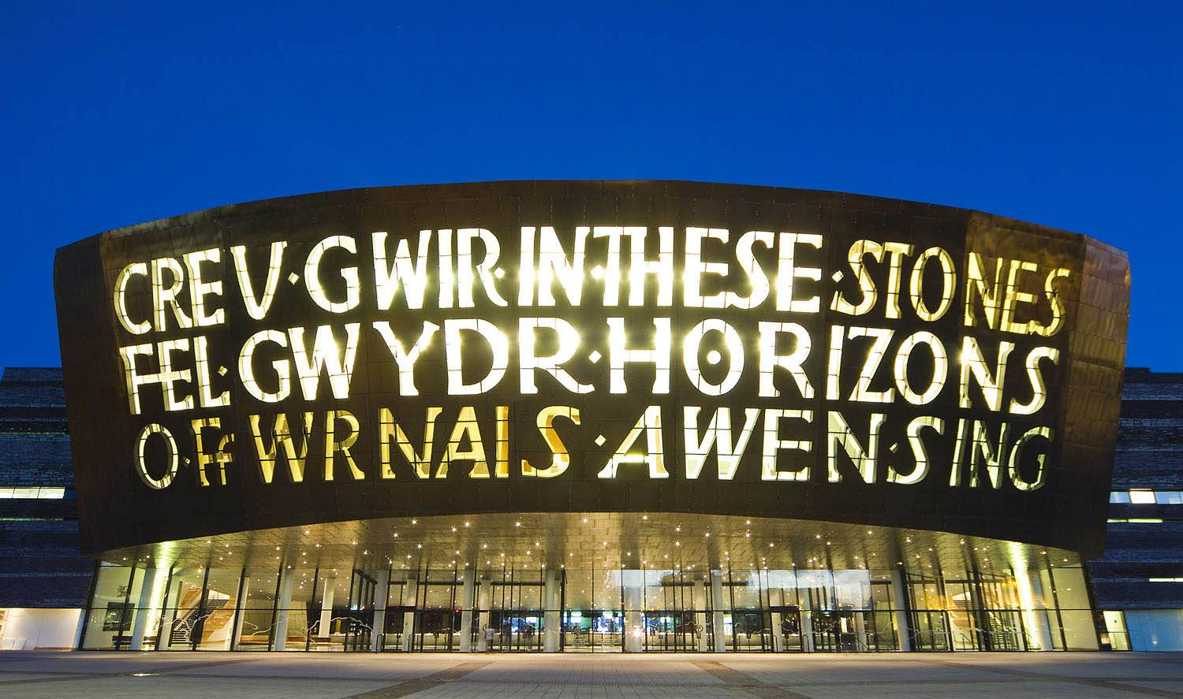
Cardiff Millennium Centre Food & Beverage Vacancies

All of the details are on their website including role profile, application form & closing date
To apply - Latest vacancies | Wales Millennium Centre (wmc.org.uk)

F&B Operations Supervisor
F&B Operations Manager
F&B Project Manager

Civil Service Jobs - 7th June 2021


Construction Vacancies


Newport Bus Vacancies
With over 30 Driving Vacancies available. Newport Bus welcome all applicants and are eager to support:
- Refugees; Asylum Seekers; Previously Homeless; ESOL Customers; Victims of Domestic Violence; Mental/Physical health conditions (Where reasonable adjustments can be made); BAME
Please see attached: Additional Information/How to Apply:

Local Authorities Vacancies
Newport City Council
Rhondda Cynon Taf County Borough Council
Bridgend Borough Council
Caerphilly County Borough Council
Merthyr Tydfil County Borough Council
Monmouthshire County Council
Torfaen County Borough Council


NHS Wales Vacancies


Google Career Certificates - Free Scholarship Programme

Google has partnered with DWP to offer free flexible online IT training for 9,000 jobseekers across the UK, developed by Google. Expectation is for a learner to complete one course by 15 December 2021. Learners are not limited to a single course they can complete as many as they wish. Learners will need access to a Laptop or tablet device with Internet IT Cert worth £300 but free for over 9000 Job seekers.

The average time to complete a course:
Data Analytics - 4 weeks to complete
Project Management - 3 weeks to complete
UX Design - 5 weeks to complete
IT Support - 3 weeks to complete
Information/How to register please contact your DWP Workcoach


157 (Welsh Regiment) Army Reserves virtual MS Teams presentation
15th June 2021 – 2:00pm to 3:00pm
Sgt Emma Thomas of the 157 Regiment RLC (Royal Logistics Corps), based in Cardiff, will be giving a presentation to help our Customers get an idea of what the Army Reserves or Regular Army have to offer as a Part Time job, or a Full Time career if the Regular Army is a choice. The Regiment offers many roles as Driver, Communications Specialist, Chef, Clerk and Combat Medic Technician. They also offer the role of Officer. Sgt Thomas will be available to answer questions following the presentation. MS Teams invites will be sent out 2 days before the event. Please sign up any interested customers via this link.


Adecco for Amazon recruiting for Warehouse Operatives in Newport; Bristol & Port Talbot.

Adecco, the sole supplier of vacancies at Amazon are supporting Amazon to fulfil supplies to local communities. Warehouse Operatives are at the heart of what Amazon does.
From the moment an order is placed to the moment it is in the customer’s hands - it will be your job to receive, pick, pack, sort and ship parcels. You’ll be expected to work to the highest standards to make sure Amazon exceeds customer expectations.
Tasks may include:
- Efficiently and effectively receiving & sorting goods into relevant post codes following Amazon's internal processes and procedures and using radio frequency (RF) scanners
- Pick our customer orders ensuring a high level of quality and productivity
- Accurately pick and sort our customer orders to ensure we meet customers' high expectations
- Accurately staging, feeding the lines & resorting mis-sorts
- Accurately read instructions from a scanner
- Consistently achieve Minimum Acceptable Performance Standard (MAPS) set for your department
- Adhere to strict safety, quality and production standards
Health and safety are a top priority with all of Amazon’s roles and sites. Our client continues to consult with medical and health experts, and take all recommended precautions in buildings and stores to keep people healthy. Our client has taken measures to promote social distancing in the workplace and taken on enhanced and frequent cleaning, to name just a few.

Margam (Port Talbot) - How to Apply
Newport - How to Apply
Avonmouth, Bristol - DBS2 - How to Apply & SBS2 - How to Apply



Gwent Police Vacancies
Gwent Police are particularly keen to receive applications from people that have a Black, Asian or other ethnic minority background (including non-visible ethnic minorities). We are also particularly interested in applications from people who identify as LGBT+ and disabled.

Exploitation and Vulnerability Trainer - We Don't Buy Crime - Newport Central Police Station
Hours per week: 30 - Salary: £29,793 - £31,725 (pro rata)
Exploitation and Vulnerability Trainer - We Don't Buy Crime - Police Jobs Wales (tal.net)
Positive Action Outreach Worker (2 year fixed term contract) - Vantage Point
Hours per week: 37 - Salary: £26,865 -£28,725
Positive Action Outreach Worker (2 year fixed term contract) - Police Jobs Wales (tal.net)
Fleet Administrative Assistant - Gwent Police Headquarters
Hours per week: 37– Salary: £19,452 - £20,706
Fleet Administrative Assistant - Police Jobs Wales (tal.net)
POP Officer - Newport Central Police Station
Hours per week: 37 - Salary: £23,817 - £26,016
POP Officer - Police Jobs Wales (tal.net)
Intelligence Research Officer, Triage - Gwent Police Headquarters
Hours per week: 37 - Salary: £21,135 – £23,406
Intelligence Research Officer, Triage - Police Jobs Wales (tal.net)


Total Security Services Vacancies
TSS Careers

