

Vacancies - Reducing BAME Employment Gap

Additional Vacancies

Week Commencing 31st May 2021





**Cardiff Bus Recruitment**

Have several different roles they are looking to recruit for these are: -

* Service Delivery Manager
* Garage Operative (Grade 2)
* Bus Driver (PCV licence holder)
* Trainee Bus Driver

They can apply via the Cardiff Bus [website](https://www.networxrecruitment.com/v?id=CARDIFFBUS&t=current-vacancies)

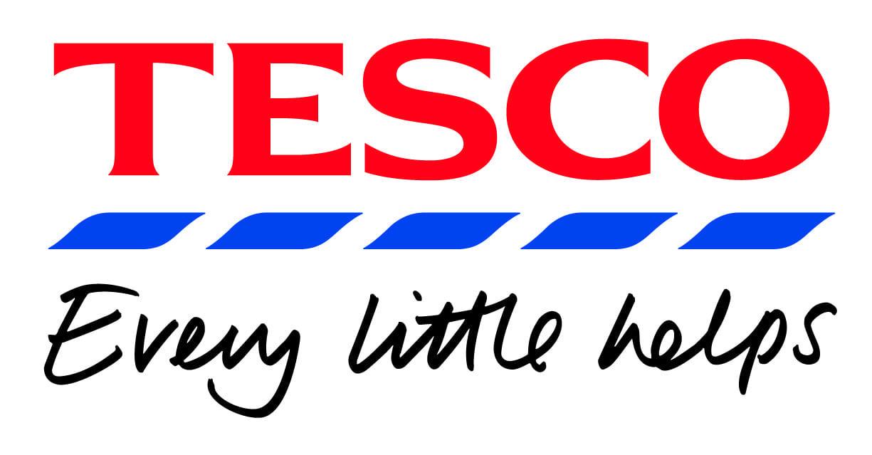

**Tesco – Avonmouth Recruitment**

At Tesco everyone is welcome and has the opportunity to get on. Fostering a diverse and inclusive culture is at the core of how we do business. It is embedded in our values: We treat people how they want to be treated.

We are looking for around 50 new colleagues to join us.

We have a new shift pattern available that may interest people wishing to reduce travel costs but still work full time hours – 40 hours are available over a 4 day from any 7 pattern (including weekend working) on both Double Day & Night Shifts.

We also have the normal 5-day pattern – part-time considered if our peak days can be included in the pattern. Job Adverts open now at [www.tesco-careers.com](http://www.tesco-careers.com)



**Jobcentre Plus has teamed up with Microsoft to offer four online workshops to customers.**

Four workshop sessions covering CVs and cover letters, building your online brand through LinkedIn, preparing for interview success & learning the fundamentals of Office 365. Each workshop is delivered by an expert Microsoft Store associate via Microsoft Teams. During the workshop you can interact and ask questions via the instant chat facility.

* Open to all customers
* Delivered via Teams, accessible to all through an open link
* Rock your LinkedIn profile - Tues 8th June 14:00 – 15:00
* Prepare for Job interview success - Thurs 10th June 15:00 – 15:30
* Fundamentals of Office 365 - Tues 15th June 14:00 – 15:00
* Make your CV stand out with CV Assistant - Thurs 17th June 14:00 – 14:30

For more information and how to register please contact your DWP Workcoach