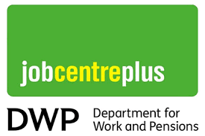
Vacancies - Reducing BAME Employment Gap
Week Commencing 21st June 2021


The Kickstart Scheme is a 6 month paid job placements for 16 to 24 year olds on Universal Credit who are at risk of long term unemployment. Work with a local employer, funded by the Government. It provides a fully funded opportunity for young people to gain experience of working in some of Britain’s most exciting companies.
The placements are available enabling you to learn new skills and acquire a sound knowledge of the company, working 25 hours per week, 6 months paid at National Minimum Wage, learn new skills, variety of opportunities with lots of employers available.
Interested in a Kickstart Placement:
- Please contact your DWP Workcoach for more information about the Kickstart placements available.

Journal Message Black and minority ethnic (BAME) candidates are encouraged to apply for a Kickstart Placement - The Kickstart Scheme is a 6 month paid job placements for 16 to 24 year olds on Universal Credit who are at risk of long term unemployment. with a local employer, funded by the Government. It provides a fully funded opportunity for young people to gain experience of working in some of Britain’s most exciting companies. The placements are available enabling you to learn new skills and acquire a sound knowledge of the company, working 25 hours per week, 6 months paid at National Minimum Wage, learn new skills, variety of opportunities with lots of employers available.
Interested in a Kickstart Placement:
- Please contact your DWP Workcoach for more information about the Kickstart placements available.


As explained in the job adverts Kickstart provides 6 month placements for those aged 18-24 who currently receive universal credit. Applicants must have a referral for these roles from their Department of Work and Pensions WorkCoach.
All job adverts have been translated into Urdu, Arabic, Somali and Bangladeshi, these can be accessed by clicking on the Available Documents button.
Kickstart Business Support Assistant
Kickstart Finance Administration Support
Kickstart HR Administration Assistant
Kickstart Maintenance Support Assistant
Kickstart Trainee ICT Assistant

Post Code Search CF24 5LQ
To apply Please contact your DWP Workcoach

Closing Date: Monday 05 July 2021


Cardiff Council

Please quote relevant Post Code applicable to the attached Kickstart Vacancy.
To apply Please contact your DWP Workcoach


Modest Trends
Modest Trends is always on the lookout for new and upcoming brands! The UK is the leader in Modest Fashion. From Instagram to YouTube, UK influencers have always led the way in Modest Fashion.
We love creativity and designs that are affordable, practical and stylish. We are especially interested in brands that cater for British Muslims.

All positions: Home working:
- Sales Representative
- Website Developer
- Social Media Co-ordinator
- Project Co-ordinator
- Operations and Logistics Co-ordinator
- Content Creator/Photographer

Closing Date - 9/07/2021
Please quote Post Code Search CF11 9LJ

To apply Please contact your DWP Workcoach

Kickstart highlighted on Twitter for SE Wales - W/C 21st June 2021.

Employer Name | Job Title | Local Authority
Hurryflow Ltd  The Bear Hotel  The Penny Farthing | 1.Kitchen/Trainee Chef  2.Front of House | Barry
Fusion Occupational Health | Telemarketing Assistant | Caerphilly
Huxley Ecommerce Limited | Marketing Assistant | Vale of Glamorgan
Hide at St Donats | Housekeeper and booking assistant | Llantwit Major/Vale of Glamorgan
Frs contractors solutions ltd | Registrations administrator | Penarth
Medical Aesthetics Training | Beauty Therapist | Risca/Caerphilly
HELLO MY PA LTD | Digital Marketing Assistant | Caerphilly
Marcar Media Ltd | Media Sales Executive | Cardiff Alex House
Team Metalogic | 1.Provisioning Support Technician  2.Office Support Apprentice | Caerphilly
Country Connect | Customer Service Assistant Trainee



Civil Service Vacancies - Bilingual (Welsh/English) Work Coach – South Wales
The application is a 500-word statement based on three criteria:
- The ability to proficiently write and conduct conversations in Welsh.
To Communicate well with a diverse group of customers, training providers and employers with the ultimate aim of supporting people into work.;
- High quality applicants will excel at coaching through a range of face to face and digital mediums whilst being sensitive and having good judgement with a considered approach to a range of situations;
We have the following locations and aim to have a reserve list to fill any future posts which become available:
- Abergavenny
- Caldicot
- Cardiff
- Chepstow
- Merthyr Tydfil
- Newport
Applications close on 28/06/2021.


Latest Civil Service Job - 21st June 2021

Various Vacancies

Location | Employer | Link
Bridgend | Bridgend Borough County Council | Young Person Support Worker
Bridgend | Bridgend Borough County Council | Clerical Assistant
Bridgend | Bridgend Borough County Council | Learning Support Assistant
Bridgend | Bridgend Borough County Council | Cynorthwyydd Cymorth Anghenion Arbennig Wrth Gefn
Bridgend | Bridgend Borough County Council | Placement Support worker
Bridgend | Bridgend Borough County Council | Lead Worker
Bridgend | Bridgend Borough County Council | Relief General Kitchen Assistant
Cardiff | Royal Mail | Postperson with Driving
Cardiff | Tesco | Production Operator RBM
Cardiff | Cardiff Council | ADVICE OFFICERS
Cardiff | ASDA | Section Leader
Cardiff | Cardiff Council | MAINTENANCE PERSON
Llantrisant | ASDA | Store Assistant - Days
Cardiff | Cardiff Council | ADMINISTRATIVE ASSISTANT
Cardiff | Tesco | Customer Assistant - Express
Cardiff | Aldi | Warehouse Deputy (Days)
Cardiff | Cardiff Council | KENNEL ASSISTANT
Leckwith | ASDA | Store Assistant - Days
Leckwith | ASDA | Online Service Colleague - Days
Leckwith | ASDA | Store Assistant - Nights
Cardiff | Cardiff Bus | Trainee Bus Driver
Cardiff | Cardiff Council | WASTE OFFICER
Cardiff | Aldi | Store Assistant (Fixed Term)
Cardiff | South Wales Police | Case Reviewer
Cardiff | Iceland | Retail Assistant (Part Time - 7.5 Hour Contract)
Cardiff | Cardiff Council | English Headings
Bridgend | Cwm Taf Morgannwg University Health Board | Emergency Department Assistant


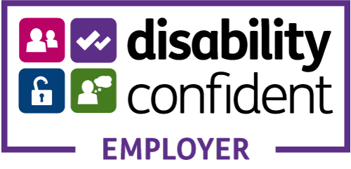
We are Pobl. We work together as a team. We have great ideas, masses of experience and a huge passion for delivering a difference in people’s lives.

careers/our-jobs


Vacancies available
Cardiff
Bridgend
Monmouthshire
Merthyr Tydfil
Newport
Blaenau Gwent
Rhondda Cynon Taff
Torfaen
Caerphilly
229 × 209
POBL - job-mail-alert

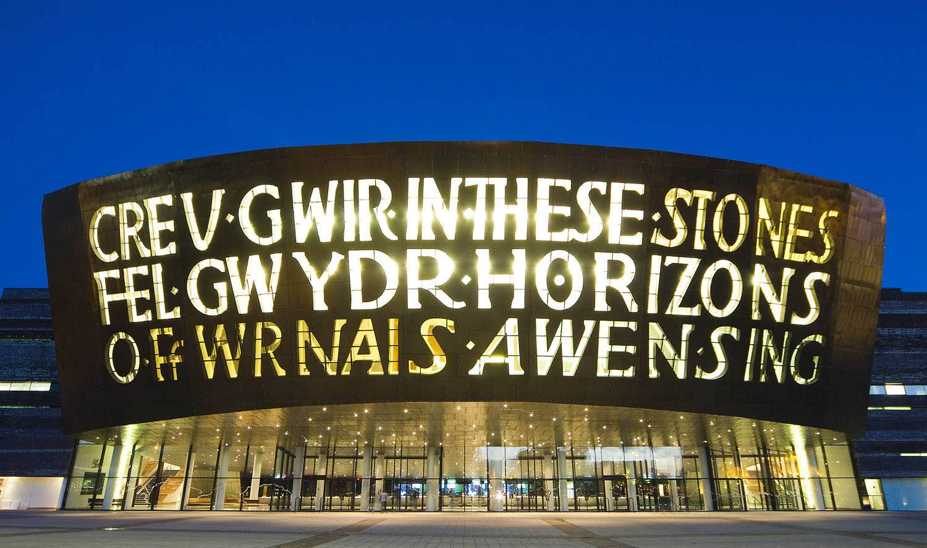
Cardiff Millennium Centre Vacancies
We're a fun, vibrant and exciting organisation to work for.
So, whether you're building stage sets for our productions, creating content for our digital platforms, finding IT solutions, keeping customers happy front of house or working with local community groups - there's plenty of opportunities for an exciting and fulfilling career here.
All of the details are on their website including role profile, application form & closing date
To apply - Latest vacancies | Wales Millennium Centre (wmc.org.uk)


All Wales Public Service Graduate Programme - Gwasanaeth Cyhoeddus Cymru Gyfan: Rhaglen i Raddedigion

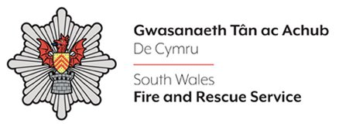
Fire Authorities - Vacancies
South Wales Vacancies


Newport Bus Vacancies
With over 30 Driving Vacancies available. Newport Bus welcome all applicants and are eager to support:
- Refugees; Asylum Seekers; Previously Homeless; ESOL Customers; Victims of Domestic Violence; Mental/Physical health conditions (Where reasonable adjustments can be made); BAME
Please see attached: Additional Information/How to Apply:

Local Authorities Vacancies
Newport City Council
Rhondda Cynon Taf County Borough Council
Bridgend Borough Council
Caerphilly County Borough Council
Merthyr Tydfil County Borough Council
Monmouthshire County Council
Torfaen County Borough Council


Head of Service
charityjobfinder.co.uk/company/Home4U

Are you a beauty fan? Do you have customer service or retail experience?
Avon will provide you with all the tools and training you need, to run your own beauty retail business online or offline. All you need is a mobile phone and the right attitude.
If you think you've got what it takes, contact michelle.wilmott@avon.com Tel 07734 878393 and find out more here - https://www.shopwithmyrep.co.uk/become-a-representative/



NHS Wales Vacancies

Finance Administrator (Fixed term contract 6 months) vacancy our website.
Job can be found here and has been translated into Urdu, Somali, Bangladeshi and Arabic. Click on documents available button to access translations CCHA Recruitment


Acorn Recruitment are involved in a pilot for a TV show on channel 4 where the aim is to work on unconscious bias. Basically it’s an opportunity for a disguised interview so the interviewers don’t know anything about your appearance, voice, age etc. A pure interview.

On offer at this stage is work experience and mentoring from Encon construction but on top of that it’s something pretty call to say you have done!!

If you are looking at construction as a career but maybe is struggling with interviews or is worried about unconscious bias. For anyone interested or for more information - please email ETJ@RDFtelevision.com by June 20th 2021

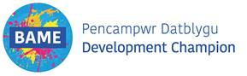

Gwent Police Vacancies
Gwent Police are particularly keen to receive applications from people that have a Black, Asian or other ethnic minority background (including non-visible ethnic minorities). We are also particularly interested in applications from people who identify as LGBT+ and disabled.
Project Support Officer - Police Jobs Wales (tal.net)
Post: Project Support Officer (part time) - Salary: £23,817 - £26,016 pro rata
Hours per week: 25 hours – Location: Police HQ, Croesyceiliog
Project Manager - Police Jobs Wales (tal.net)
Post: Project Manager - Salary: £32,673-£34,578
Hours per week: 37 Hours - Location: Police HQ, Croesyceiliog
HR Business Partner - Police Jobs Wales (tal.net)
Post: HR Business Partner - Salary: £35,484 - £38,376
Hours per week: 37 Hours - Location: Vantage Point, Cwmbran
Closing Date: 02/07/21 @1PM


Teaching Assistants and Learning Support Assistants across Cardiff
Teaching Assistants - Cardiff
Teaching Assistant Vacancy – Mountain Ash
Teaching Assistant - Mountain Ash
Learning Support Assistants – Newport & Torfaen & Monmouthshire Areas
Learning Support Assistants – Newport - Learning Support Assistants – Torfaen
Newport, Torfaen & Monmouthshire Areas only - The role of the TA/LSA would be working (Mainstream schools - mainly primary) 1:1 or with small groups of children. Pay Rate- £61.25 day/working hours 8:30 – 15:30. Applicants would need a minimum of 3 months working with children or a child base qualification. We would also accept candidates with transferrable skills such as Carers/Sports Coaches/Dance Teachers etc. I would be able to offer ad-hoc or long term roles, whichever suites best. Candidates can contact me direct: Garth.noot@new-directions.co.uk
What makes New Directions Education different? With two decades of experience, and registering over 250,000 jobs in schools, colleges and universities each year, we are committed to finding education staff the right job, the first time. The benefits of working with us include:

Guaranteed payment scheme
FREE continuous professional development for candidates
Competitive rates of pay
 Industry events and conferences
See All Job Vacancies
Register online, add your CV, and start looking for tailored vacancies in your area Register online

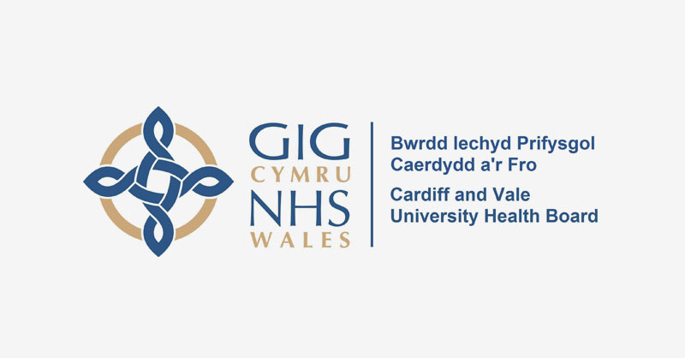
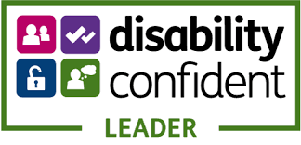

Cardiff and Vale University Health Board Vacancies

We are a teaching health board with close links to Cardiff University. The University boasts a high profile teaching, research and development role within the UK and abroad. Together we are training the next generation of medical professionals

We have vacancies in the following sectors
Nursing & Midwifrey; Medical & Dental; Allied Health Professionals; Health Science Services; Support Services & Administrative Services

Cardiff & Vale University Health Board Vacancies


Adecco for Amazon recruiting for Warehouse Operatives in Newport; Bristol & Port Talbot.

Adecco, the sole supplier of vacancies at Amazon are supporting Amazon to fulfil supplies to local communities. Warehouse Operatives are at the heart of what Amazon does.
From the moment an order is placed to the moment it is in the customer’s hands - it will be your job to receive, pick, pack, sort and ship parcels. You’ll be expected to work to the highest standards to make sure Amazon exceeds customer expectations.
Tasks may include:
- Efficiently and effectively receiving & sorting goods into relevant post codes following Amazon's internal processes and procedures and using radio frequency (RF) scanners
- Pick our customer orders ensuring a high level of quality and productivity
- Accurately pick and sort our customer orders to ensure we meet customers' high expectations
- Accurately staging, feeding the lines & resorting mis-sorts
- Accurately read instructions from a scanner
- Consistently achieve Minimum Acceptable Performance Standard (MAPS) set for your department
- Adhere to strict safety, quality and production standards
Health and safety are a top priority with all of Amazon’s roles and sites. Our client continues to consult with medical and health experts, and take all recommended precautions in buildings and stores to keep people healthy. Our client has taken measures to promote social distancing in the workplace and taken on enhanced and frequent cleaning, to name just a few.

Margam (Port Talbot) - How to Apply
Newport - How to Apply
Avonmouth, Bristol - DBS2 - How to Apply & SBS2 - How to Apply

